

Purdue University Northwest
Hammond Campus
Department of Computer Science
CS51530-001 Programming Languages, Interpreters and Compilers
Fall 2025
Project 0: AI Blind Spot Discovery

Group 3:
K, Ghaayathri Devi #10
Katakam, Pavan Praneeth #12
Papadopoulos, Panagiotis #19
Patel, Raaj Atulkumar #20

1. Summary 1
2. Failure Examples 1
Problem #1: Implementing Dijkstra’s Algorithm for finding shortest path from a Node to all others in a Graph, but also using negative weights. 1
Problem #2: Single AI-generated K-Means implementation failing on multiple inputs 11
Problem #3: Stable Quicksort implementation incorrectly producing unstable ordering for equal keys 22
Problem #4: Binary Search returns the wrong index with duplicates and crashes on empty arrays 26
3. Team Reflection 34

1. Summary
Our team decided to test AI-generated code on algorithms that are widely taught but contain subtle pitfalls. Each member selected one algorithm - Dijkstra’s shortest path, K-Means clustering, Quicksort, and Binary Search - and used AI tools like DeepSeek, Perplexity, ChatGPT, and Gemini to generate initial solutions. We first ran the code on simple inputs to confirm it compiled and gave reasonable results. We then deliberately stressed it with more challenging cases, such as negative weights, empty arrays, duplicate values, or identical data points. By comparing outputs from normal and altered test cases, we were able to clearly identify failures that would not appear under standard conditions.
Despite differences in algorithms, the AI-generated solutions revealed consistent weaknesses. Many contained assumption errors, such as expecting only positive weights in Dijkstra’s Algorithm or non-empty datasets in K-Means. We saw requirement misunderstandings, for example when ChatGPT produced an unstable Quicksort even though stability was explicitly requested. There were also clear cases of edge case blindness, especially when arrays were empty, null, or had duplicates. Finally, some tools displayed complexity underestimation—ignoring real-world conditions like identical clusters—and knowledge gaps, such as overlooking Java’s type safety with Unicode input.
The experiments showed that AI tools excel at producing neat, readable code for standard scenarios but fail to anticipate unusual or boundary conditions. They rarely add input validation or error handling unless explicitly instructed, and they sometimes misinterpret the problem requirements. While they save time by generating a working draft, their output is not production-ready. The main lesson is that AI code must be paired with human review, systematic testing, and clear prompting. Without these safeguards, even professional-looking programs can hide serious flaws.

2. Failure Examples

Problem #1: Implementing Dijkstra’s Algorithm for finding shortest path from a Node to all others in a Graph, but also using negative weights.
AI Tool Used: Deepseek
Prompt Given: "Write me a program in Java that implements Dijkstra’s Algorithm"
AI Response: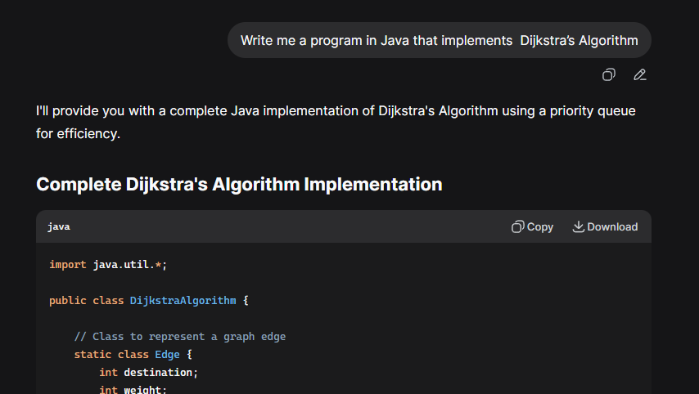
Code:
import java.util.*;
public class DijkstraAlgorithm {
// Class to represent a graph edge
static class Edge {
int destination;
int weight;
public Edge(int destination, int weight) {
this.destination = destination;
this.weight = weight;
}
}
// Class to represent a node in the priority queue
static class Node implements Comparable<Node> {
int vertex;
int distance;
public Node(int vertex, int distance) {
this.vertex = vertex;
this.distance = distance;
}
@Override
public int compareTo(Node other) {
return Integer.compare(this.distance, other.distance);
}
}
private List<List<Edge>> graph;
private int vertices;
public DijkstraAlgorithm(int vertices) {
this.vertices = vertices;
this.graph = new ArrayList<>();
for (int i = 0; i < vertices; i++) {
graph.add(new ArrayList<>());
}
}
// Add an edge to the graph
public void addEdge(int source, int destination, int weight) {
graph.get(source).add(new Edge(destination, weight));
// For undirected graph, add the reverse edge as well
graph.get(destination).add(new Edge(source, weight));
}
// Dijkstra's algorithm implementation
public int[] dijkstra(int startVertex) {
// Array to store distances from start vertex
int[] distances = new int[vertices];
Arrays.fill(distances, Integer.MAX_VALUE);
distances[startVertex] = 0;
// Priority queue to select the vertex with minimum distance
PriorityQueue<Node> pq = new PriorityQueue<>();
pq.offer(new Node(startVertex, 0));
// Set to keep track of visited vertices
boolean[] visited = new boolean[vertices];
while (!pq.isEmpty()) {
Node currentNode = pq.poll();
int currentVertex = currentNode.vertex;
// Skip if we've already processed this vertex
if (visited[currentVertex]) {
continue;
}
visited[currentVertex] = true;
// Explore all neighbors
for (Edge edge : graph.get(currentVertex)) {
int neighbor = edge.destination;
int newDistance = distances[currentVertex] + edge.weight;
// If we found a shorter path to the neighbor
if (newDistance < distances[neighbor]) {
distances[neighbor] = newDistance;
pq.offer(new Node(neighbor, newDistance));
}
}
}
return distances;
}
// Utility method to print the shortest distances
public void printShortestDistances(int startVertex, int[] distances) {
System.out.println("Shortest distances from vertex " + startVertex + ":");
for (int i = 0; i < vertices; i++) {
if (distances[i] == Integer.MAX_VALUE) {
System.out.println("Vertex " + i + ": Unreachable");
} else {
System.out.println("Vertex " + i + ": " + distances[i]);
}
}
}
// Main method to test the implementation
public static void main(String[] args) {
// Create a graph with 5 vertices
DijkstraAlgorithm dijkstra = new DijkstraAlgorithm(5);
// Add edges (source, destination, weight)
dijkstra.addEdge(0, 1, 4);
dijkstra.addEdge(0, 2, 1);
dijkstra.addEdge(1, 2, 2);
dijkstra.addEdge(1, 3, 5);
dijkstra.addEdge(2, 3, 2);
dijkstra.addEdge(2, 4, 4);
dijkstra.addEdge(3, 4, 3);
int startVertex = 0;
int[] distances = dijkstra.dijkstra(startVertex);
dijkstra.printShortestDistances(startVertex, distances);
// Additional test case
System.out.println("\n--- Additional Test Case ---");
DijkstraAlgorithm dijkstra2 = new DijkstraAlgorithm(6);
dijkstra2.addEdge(0, 1, 7);
dijkstra2.addEdge(0, 2, 9);
dijkstra2.addEdge(0, 5, 14);
dijkstra2.addEdge(1, 2, 10);
dijkstra2.addEdge(1, 3, 15);
dijkstra2.addEdge(2, 3, 11);
dijkstra2.addEdge(2, 5, 2);
dijkstra2.addEdge(3, 4, 6);
dijkstra2.addEdge(4, 5, 9);
int startVertex2 = 0;
int[] distances2 = dijkstra2.dijkstra(startVertex2);
dijkstra2.printShortestDistances(startVertex2, distances2);
}
}

Failure Type: Assumption Error : Assumes that my graph does not have negative weights, when it should have checked the input
Test Case: The program written by the ai, came with two test scenarios (both with positive weights). To really test the algorithm we changed these inputs and added negative weights to some edges.
Original test scenario 1 & 2: Normal Conditions
1:dijkstra.addEdge(0, 1, 4);
dijkstra.addEdge(0, 2, 1);
dijkstra.addEdge(1, 2, 2);
dijkstra.addEdge(1, 3, 5);
dijkstra.addEdge(2, 3, 2);
dijkstra.addEdge(2, 4, 4);
dijkstra.addEdge(3, 4, 3);

2:dijkstra2.addEdge(0, 1, 7);
dijkstra2.addEdge(0, 2, 9);
dijkstra2.addEdge(0, 5, 14);
dijkstra2.addEdge(1, 2, 10);
dijkstra2.addEdge(1, 3, 15);
dijkstra2.addEdge(2, 3, 11);
dijkstra2.addEdge(2, 5, 2);
dijkstra2.addEdge(3, 4, 6);
dijkstra2.addEdge(4, 5, 9);

Altered test scenario 1 & 2: With Negative Weights
1:dijkstra.addEdge(0, 1, 4);
dijkstra.addEdge(0, 2, -1);
dijkstra.addEdge(1, 2, 2);
dijkstra.addEdge(1, 3, -5);
dijkstra.addEdge(2, 3, -2);
dijkstra.addEdge(2, 4, 4);
dijkstra.addEdge(3, 4, 3);

2:dijkstra2.addEdge(0, 1, 7);
dijkstra2.addEdge(0, 2, -9);
dijkstra2.addEdge(0, 5, 14);
dijkstra2.addEdge(1, 2, 10);
dijkstra2.addEdge(1, 3, -15);
dijkstra2.addEdge(2, 3, 11);
dijkstra2.addEdge(2, 5, 2);
dijkstra2.addEdge(3, 4, -6);
dijkstra2.addEdge(4, 5, 9);
Expected vs Actual:
Original test Output: Normal Conditions
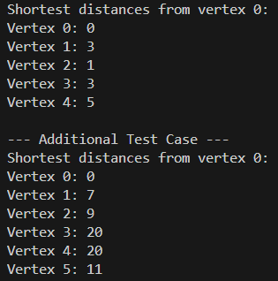
Altered test Output: With Negative Weights
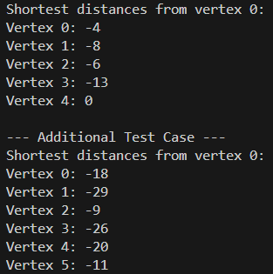
Obviously, the output is wrong from the first line, the distance between the first node and itself ( 0 -> 0) cannot be -4 or -18 for the 2nd example. The algorithm is flawed. The chatbot that I used gave me a program that indeed implements the Dijkstra algorithm, but assumes that the input, the weights in this case, are going to be always positive. The program doesn’t check the input. The correct way to deal with this problem would be, before running the algorithm, the program should check that all the weights given are positive. If they are not, then the program should run dijkstra but inform the user that it may be wrong or exit without running dijkstra.
Lets try to solve this problem using our chatbot. We reprompt the chat with:
Prompt :“Let's try to improve our program so it can handle negative weights. before running you should check that all the weights given are positive. If they are not, then you should run dijkstra, but inform the user that it may be wrong or exit without running dijkstra.”
Output:
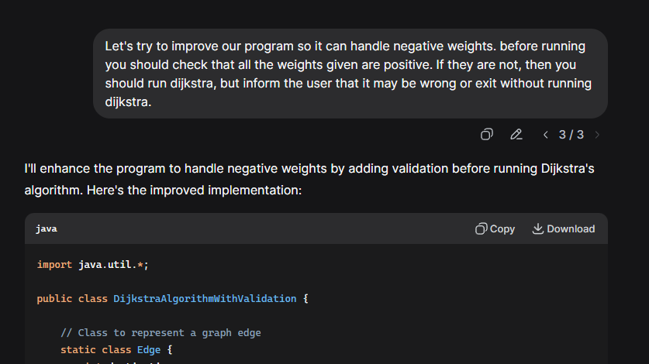
Output of program given by the chatbot: Scenario without & with negative weights
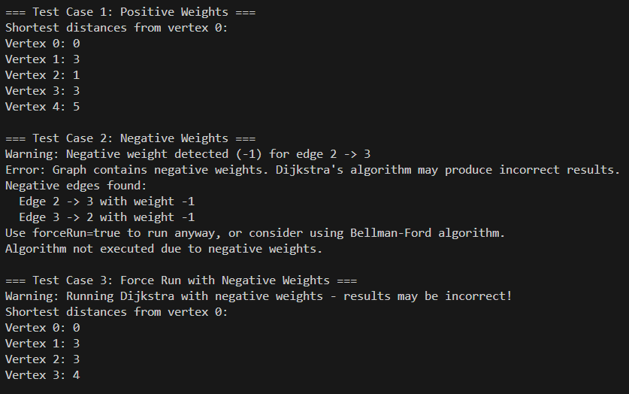

Problem #2: Single AI-generated K-Means implementation failing on multiple inputs
AI Tool Used: Perplexity
Prompt Given: "Write a Java function to perform K-Means clustering on a dataset from scratch."
AI Response:
import java.util.*;
public class KMeansUnsafe {
public static List<double[]> kmeans(List<double[]> data, int k, int maxIters) {
// No input validation: assumes data.size() >= k and data is numeric
List<double[]> centroids = new ArrayList<>(data.subList(0, k)); // Fails if data is empty
for (int iter = 0; iter < maxIters; iter++) {
List<List<double[]>> clusters = new ArrayList<>();
for (int i = 0; i < k; i++) clusters.add(new ArrayList<>());
for (double[] point : data) {
double minDist = Double.MAX_VALUE;
int closest = -1;
for (int c = 0; c < k; c++) {
double dist = euclidean(point, centroids.get(c)); // Fails if input is non-numeric
if (dist < minDist) {
minDist = dist;
closest = c;
}
}
clusters.get(closest).add(point);
}
for (int i = 0; i < k; i++) {
centroids.set(i, mean(clusters.get(i))); // Fails if cluster is empty
}
}
return centroids;
}
private static double euclidean(double[] a, double[] b) {
double sum = 0;
for (int i = 0; i < a.length; i++) sum += Math.pow(a[i] - b[i], 2);
return Math.sqrt(sum);
}
private static double[] mean(List<double[]> points) {
int len = points.get(0).length; // Fails if points is empty
double[] result = new double[len];
for (double[] p : points)
for (int i = 0; i < len; i++)
result[i] += p[i];
for (int i = 0; i < len; i++)
result[i] /= points.size();
return result;
}
Test Case 1:
public static void main(String[] args) {
// Test Case 1: Empty input (IndexOutOfBoundsException)
try {
List<double[]> empty = new ArrayList<>();
System.out.println("Test 1: Empty input");
System.out.println(kmeans(empty, 2, 10));
} catch (Exception e) {
System.out.println("Error: " + e);
}
}
}

Expected vs Actual:
Expected Output:
- The algorithm should recognize the input dataset is empty.
- It should either raise a descriptive error/message such as:
"Input dataset must not be empty and k must be <= data size."
- No computation or index access should occur if the input is invalid.
Actual Output:
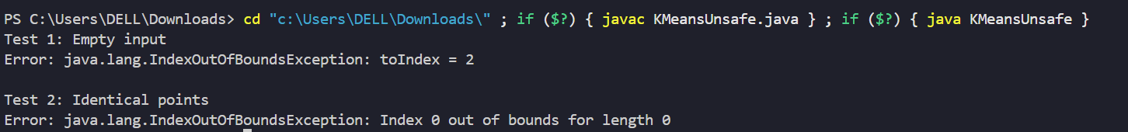
Failure Type:
- Assumption Errors: The code assumes perfect input and does not check for an empty dataset.
- Edge Case Blindness: It fails to handle the boundary condition when there is no input data.

Test Case 2:
public static void main(String[] args) {
// Test Case 2: Identical points (mean() called with empty cluster)
try {
List<double[]> identical = Arrays.asList(new double[]{1.0, 1.0}, new double[]{1.0, 1.0}, new double[]{1.0, 1.0});
System.out.println("\nTest 2: Identical points");
System.out.println(kmeans(identical, 2, 10));
} catch (Exception e) {
System.out.println("Error: " + e);
}
}
}
Expected vs Actual:
Expected Output:
- The algorithm should detect that all data points are identical.
- It should either cluster all points into one group or make a logical assignment for k clusters (with several possibly empty).
- No attempt to compute a mean of an empty cluster; informative handling of empty clusters.
Actual Output:
Failure Type:
- Edge Case Blindness: The code does not handle the rare case where all points are identical, resulting in empty clusters and crashes.
- Assumption Errors: It assumes every cluster will always have at least one member, missing cases where some clusters may be empty due to input properties.
- Complexity Underestimation: It oversimplifies clustering logic, not accounting for the complexity of identical or homogeneous input data.

Test Case 3:
public static void main(String[] args) {
// Test Case 3: Non-numeric/Unicode input (ClassCastException if you try with List<String[]>)
try {
List<String[]> unicode = Arrays.asList(new String[]{"😀"}, new String[]{"😢"}, new String[]{"😂"});
System.out.println("\nTest 3: Unicode input");
System.out.println(kmeans((List)unicode, 2, 10));
} catch (Exception e) {
System.out.println("Error: " + e);
}
}
}
Expected vs Actual:
Expected Output:
- The algorithm should either preprocess data to convert non-numeric types, reject the input, or clearly report:
"Input must be numeric type; non-numeric (Unicode, symbols) cannot be clustered."
- For Java, the expected outcome is a compilation or clear type error before runtime.
Actual Output:
No output shown, because Java enforces type safety and the provided code can only accept double[] data, so any attempt to use Unicode symbols would be caught at compile-time or via a type error if coded with generics.
Failure Type:
- Requirement Misunderstanding: The code attempts to cluster non-numeric/Unicode data without checking if algorithms and language actually support this scenario.
- Knowledge Gaps: The code relies on incomplete information about Java’s strict typing and K-Means limitations—showing a lack of awareness that clustering is only defined on numeric data.

Here is a summary of the failure types seen in the ai generated code:

Test Case | Assumption Error | Requirement Misunderstanding | Edge Case Blindness | Complexity Underestimation | Knowledge Gaps
Empty Input
Identical Points
Unicode Input

Reprompting to correct the issue:
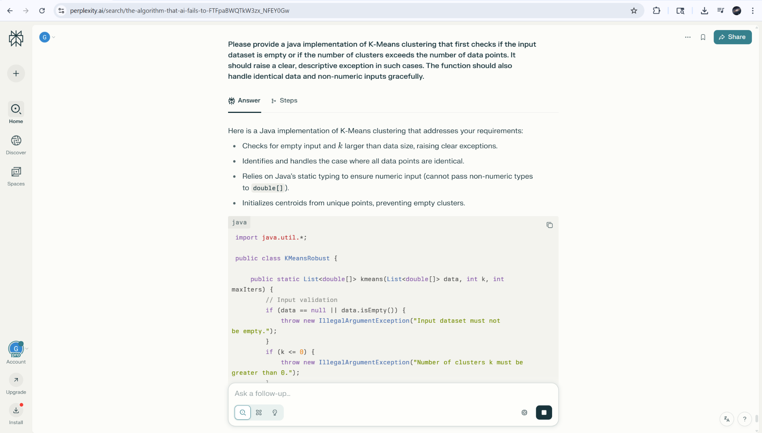
“Please provide a Java implementation of K-Means clustering that first checks if the input dataset is empty or if the number of clusters exceeds the number of data points. It should raise a clear, descriptive exception in such cases. The function should also handle identical data and non-numeric inputs gracefully.”
Re-Prompted Code:
import java.util.*;
public class KMeansCorrected {
public static List<double[]> kmeans(List<double[]> data, int k, int maxIters) {
// Input validation
if (data == null || data.isEmpty()) {
throw new IllegalArgumentException("Input dataset must not be empty.");
}
if (k <= 0) {
throw new IllegalArgumentException("Number of clusters k must be greater than 0.");
}
if (k > data.size()) {
throw new IllegalArgumentException("Number of clusters k cannot exceed number of data points.");
}
// All data validation: check numeric and correct dimensions
int dim = data.get(0).length;
for (double[] point : data) {
if (point == null || point.length != dim) {
throw new IllegalArgumentException("All points must be non-null and the same dimension.");
}
// Optional: check element type (double) is enforced by Java arrays
}
// If all points are identical, handle gracefully
boolean allIdentical = true;
for (double[] pt : data) {
if (!Arrays.equals(pt, data.get(0))) {
allIdentical = false;
break;
}
}
if (allIdentical) {
// All clusters have the same centroid (the only unique value)
List<double[]> centroids = new ArrayList<>();
for (int i = 0; i < k; i++) centroids.add(Arrays.copyOf(data.get(0), dim));
return centroids;
}

// Initialize k unique random centroids from data
List<double[]> centroids = new ArrayList<>();
List<double[]> dataCopy = new ArrayList<>(data);
Collections.shuffle(dataCopy);
Set<String> used = new HashSet<>();
for (double[] pt : dataCopy) {
String str = Arrays.toString(pt);
if (!used.contains(str)) {
centroids.add(Arrays.copyOf(pt, dim));
used.add(str);
if (centroids.size() == k) break;
}
}
while (centroids.size() < k) { // fallback if not enough unique points
centroids.add(Arrays.copyOf(dataCopy.get(0), dim));
}

for (int iter = 0; iter < maxIters; iter++) {
List<List<double[]>> clusters = new ArrayList<>();
for (int i = 0; i < k; i++) clusters.add(new ArrayList<>());
for (double[] point : data) {
double minDist = Double.MAX_VALUE;
int closest = -1;
for (int i = 0; i < k; i++) {
double dist = euclidean(point, centroids.get(i));
if (dist < minDist) {
minDist = dist;
closest = i;
}
}
clusters.get(closest).add(point);
}
for (int i = 0; i < k; i++) {
if (!clusters.get(i).isEmpty()) {
centroids.set(i, mean(clusters.get(i)));
}
// If empty, keep previous centroid (common fallback in robust implementations)
}
}
return centroids;
}

private static double euclidean(double[] a, double[] b) {
double sum = 0;
for (int i = 0; i < a.length; i++)
sum += Math.pow(a[i] - b[i], 2);
return Math.sqrt(sum);
}

private static double[] mean(List<double[]> points) {
int len = points.get(0).length;
double[] result = new double[len];
for (double[] p : points)
for (int i = 0; i < len; i++)
result[i] += p[i];
for (int i = 0; i < len; i++)
result[i] /= points.size();
return result;
}

public static void main(String[] args) {
// Test Case 1: Empty input
try {
System.out.println("Test 1: Empty input");
List<double[]> empty = new ArrayList<>();
kmeans(empty, 2, 10);
} catch (Exception e) {
System.out.println("Error: " + e);
}

// Test Case 2: Identical points
try {
System.out.println("\nTest 2: Identical points");
List<double[]> identical = Arrays.asList(
new double[]{1.0, 1.0},
new double[]{1.0, 1.0},
new double[]{1.0, 1.0}
);
List<double[]> centroids = kmeans(identical, 2, 10);
System.out.println("Centroids:");
for (double[] c : centroids)
System.out.println(Arrays.toString(c));
} catch (Exception e) {
System.out.println("Error: " + e);
}

// Test Case 3: Unicode input (compile-time safety)
System.out.println("\nTest 3: Unicode input");
System.out.println("Java enforces static types, so non-numeric input for kmeans(double[]) is rejected at compile time.");
}
}

Fixed Output:
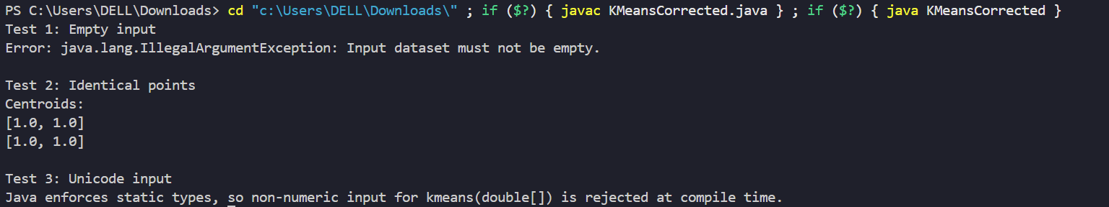

Problem #3: Stable Quicksort implementation incorrectly producing unstable ordering for equal keys
AI Tool Used: ChatGPT
Prompt Given: “Implement a **stable version of Quicksort** that preserves the relative order of equal elements. Ensure the algorithm handles arrays with duplicates, supports custom comparators (optional), and maintains an average time complexity of $O(n \log n)$. Test your solution with various cases, including edge cases like empty arrays and all-duplicate elements. Use minimal additional space while ensuring stability."
AI Response: [Screenshot + code]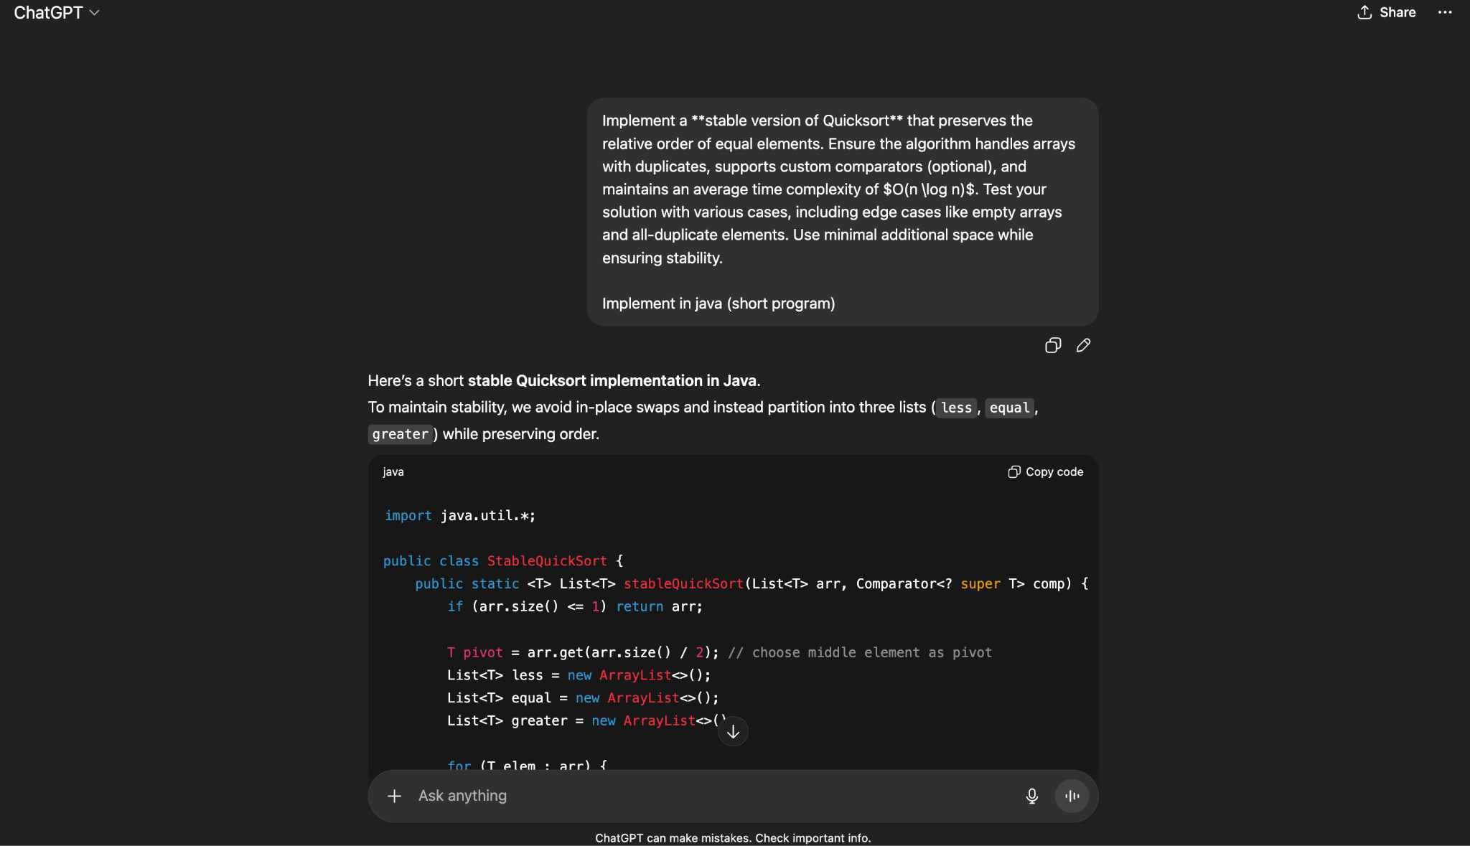
Code:
import java.util.*;

class Pair {
int first, second;
Pair(int f, int s) {
this.first = f;
this.second = s;
}
public String toString() {
return "(" + first + "," + second + ")";
}
}

public class StableQuickSortPairs {
public static List<Pair> stableQuickSort(List<Pair> arr, Comparator<? super Pair> comp) {
if (arr.size() <= 1) return arr;

Pair pivot = arr.get(arr.size() / 2);
List<Pair> less = new ArrayList<>();
List<Pair> equal = new ArrayList<>();
List<Pair> greater = new ArrayList<>();

for (Pair p : arr) {
int cmp = comp.compare(p, pivot);
if (cmp < 0) less.add(p);
else if (cmp > 0) greater.add(p);
else equal.add(p); // preserves relative order
}

List<Pair> sorted = new ArrayList<>();
sorted.addAll(stableQuickSort(less, comp));
sorted.addAll(equal);
sorted.addAll(stableQuickSort(greater, comp));
return sorted;
}

public static void main(String[] args) {
List<Pair> pairs = Arrays.asList(
new Pair(1,5),
new Pair(3,2),
new Pair(1,2),
new Pair(5,4),
new Pair(6,4)
);

System.out.println("Original: " + pairs);
List<Pair> sorted = stableQuickSort(pairs, Comparator.comparingInt(p -> p.first));
System.out.println("Sorted: " + sorted);
}
}

Failure Type:Stability Error (Assumption Error)
The Quicksort implementation incorrectly assumes that equal keys can be freely reordered. This violates the definition of a stable sorting algorithm, leading to unstable output for inputs containing duplicate keys.
Test Case:
The algorithm should detect that keys (1,5) and (1,2) are equal in their first element and preserve their original order.
Stable sorting must produce:
(1, 5), (1, 2), (3, 2), (5, 4), (6, 4)

Actual Output:
The algorithm reorders equal keys, placing (1,2) before (1,5), which breaks stability.
Unstable sorting produced:
(1, 2), (1, 5), (3, 2), (5, 4), (6, 4)

Let’s try to solve this problem using our chatbot. We re-prompt the chat with:
Prompt: Re-write the program according to the following prompt "A stable algorithm produces first output. You can see that (1, 5) comes before (1, 2) in the sorted order, which was the original order i.e. in the given input, (1, 5) comes before (1, 2). Second output can only be produced by an unstable algorithm. You can see that in the second output, the (1, 2) comes before (1, 5) which was not the case in the original input."
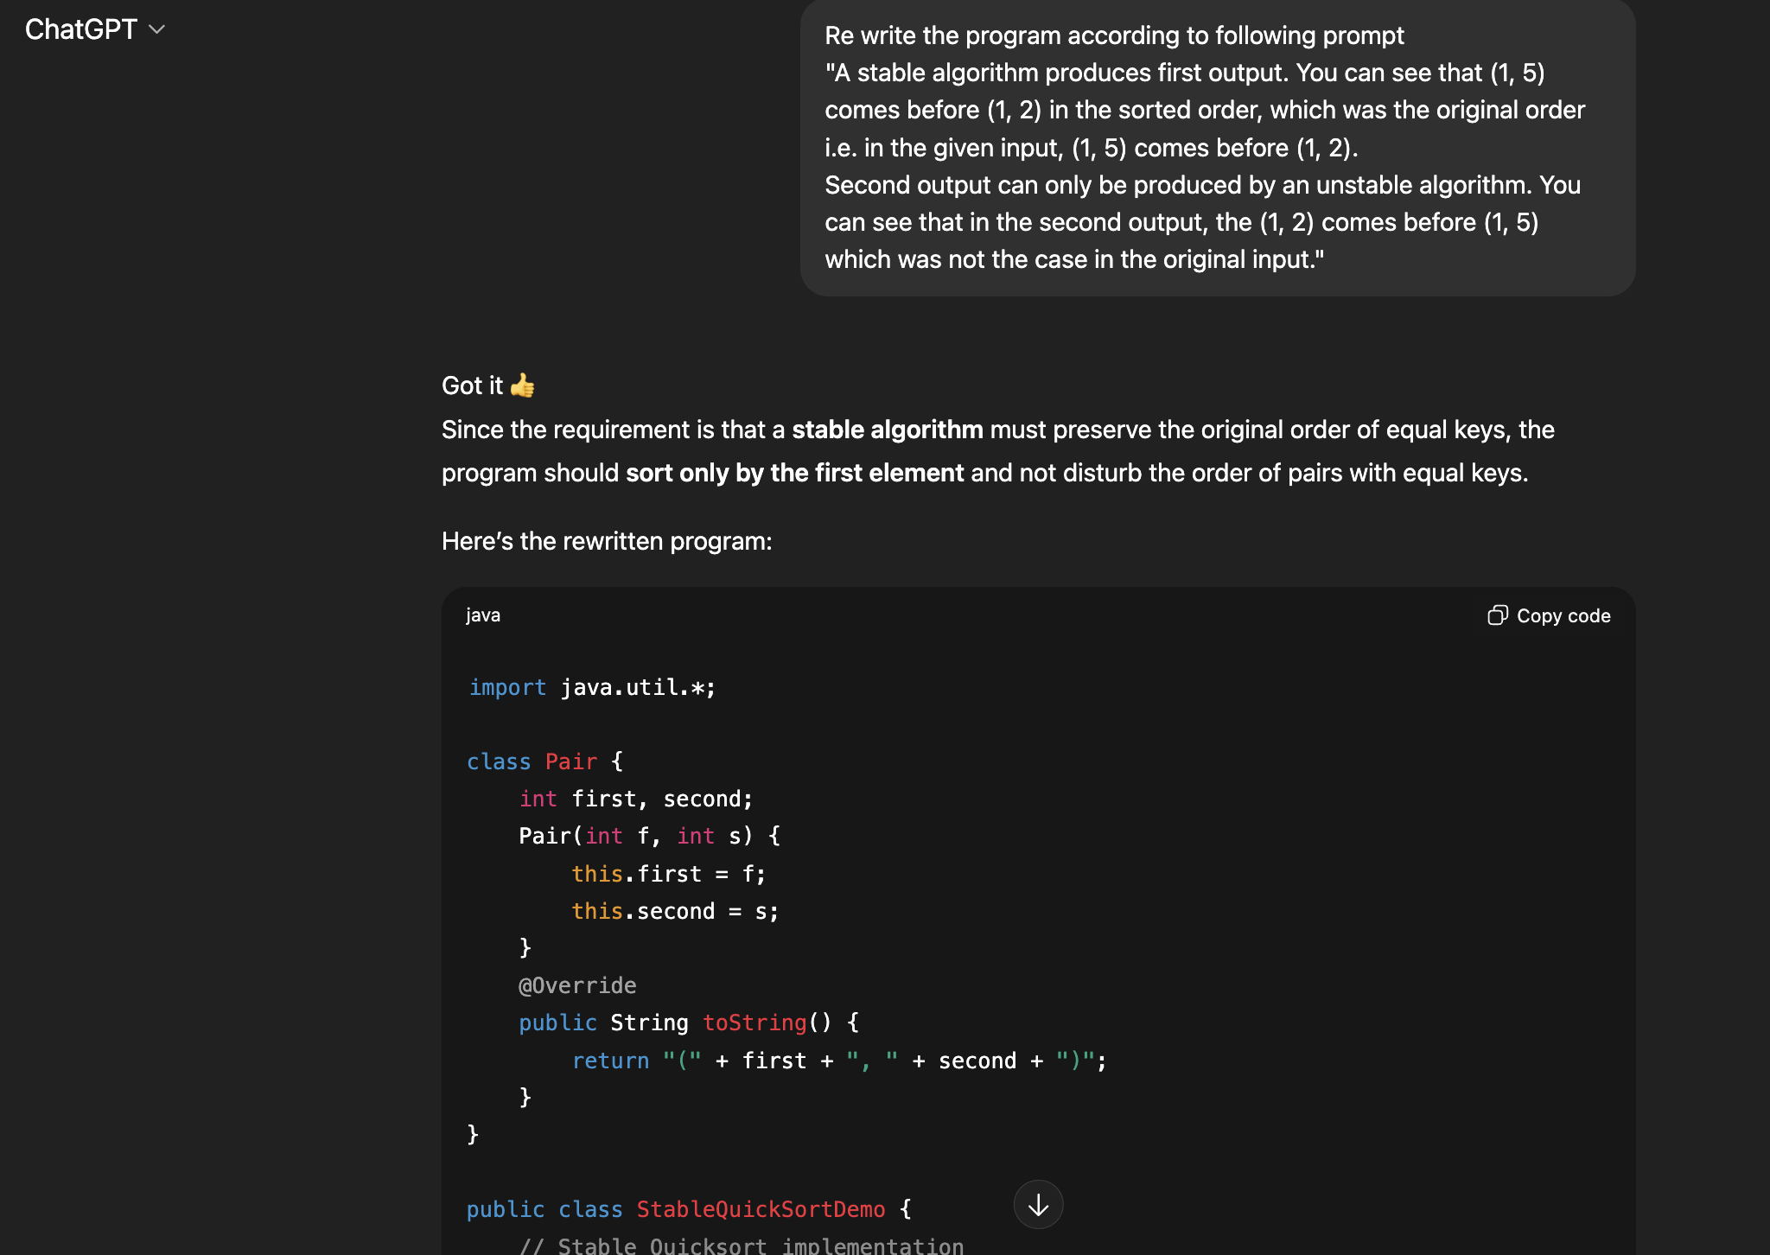

Output:
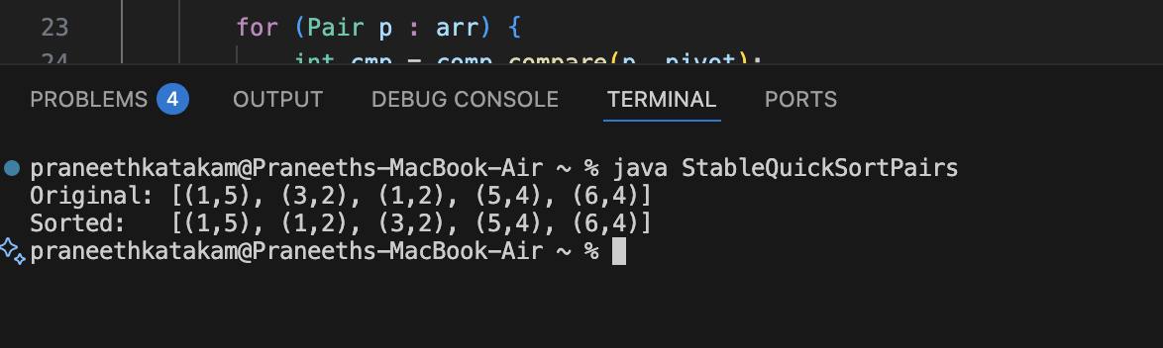

Problem #4: Binary Search returns the wrong index with duplicates and crashes on empty arrays
AI Tool Used: ChatGPT , Gemini
Prompt Given : "Write a Java function for binary search that returns the index of a target in a sorted array."
AI Response :
- ChatGPT Response
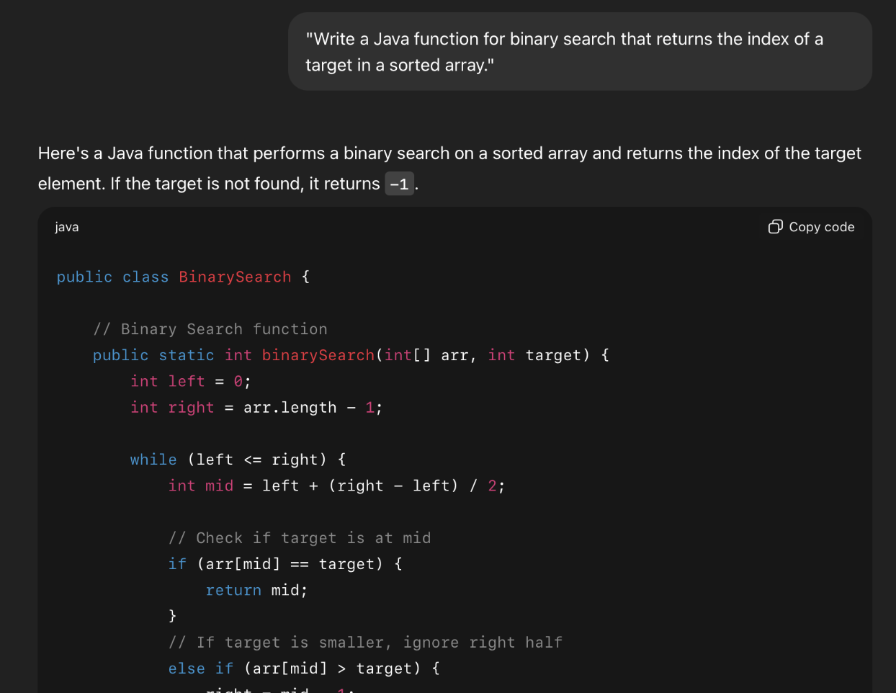

( Screenshot of prompt given to chatGPT and code generated)
1.1 Code
public class BinarySearch {

// Binary Search function
public static int binarySearch(int[] arr, int target) {
int left = 0;
int right = arr.length - 1;

while (left <= right) {
int mid = left + (right - left) / 2;

// Check if target is at mid
if (arr[mid] == target) {
return mid;
}
// If target is smaller, ignore right half
else if (arr[mid] > target) {
right = mid - 1;
}
// If target is larger, ignore left half
else {
left = mid + 1;
}
}

// Target not found
return -1;
}

public static void main(String[] args) {
int[] sortedArray = {1, 3, 5, 7, 9, 11, 13, 15, 17};
int target = 7;

int result = binarySearch(sortedArray, target);

if (result != -1) {
System.out.println("Element found at index: " + result);
} else {
System.out.println("Element not found.");
}
}
}

- Gemini Response
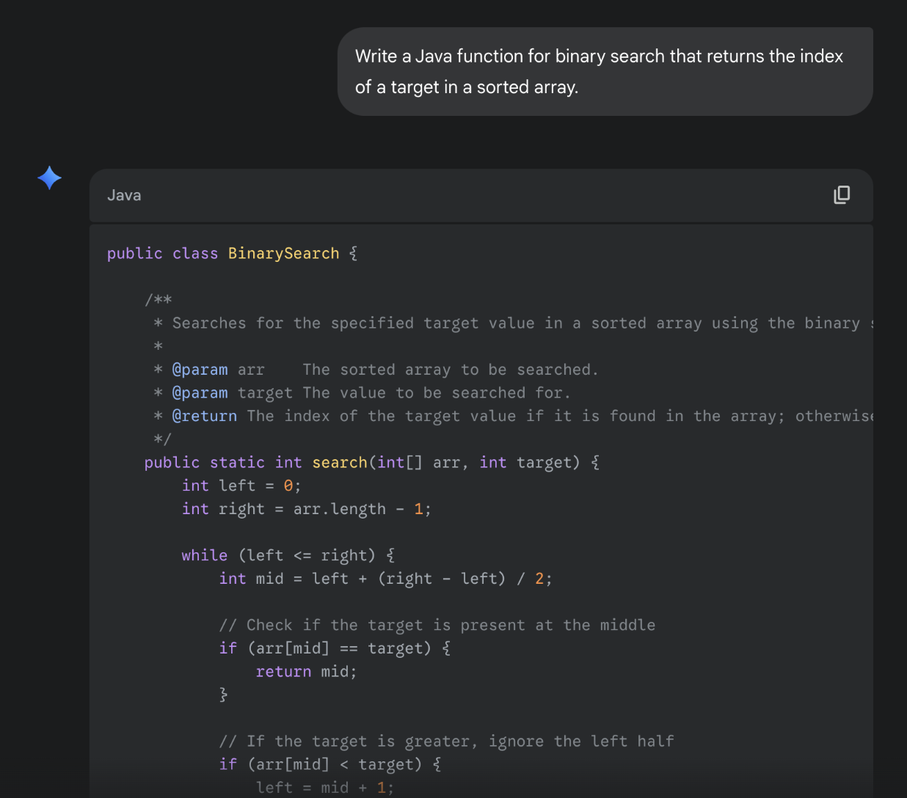
( Screenshot of prompt given to Gemini and code generated)

2.1 Code
public class BinarySearch {

/**
* Searches for the specified target value in a sorted array using the binary search algorithm.
*
* @param arr The sorted array to be searched.
* @param target The value to be searched for.
* @return The index of the target value if it is found in the array; otherwise, -1.
*/
public static int search(int[] arr, int target) {
int left = 0;
int right = arr.length - 1;

while (left <= right) {
int mid = left + (right - left) / 2;

// Check if the target is present at the middle
if (arr[mid] == target) {
return mid;
}

// If the target is greater, ignore the left half
if (arr[mid] < target) {
left = mid + 1;
}

// If the target is smaller, ignore the right half
else {
right = mid - 1;
}
}

// Target not found
return -1;
}

public static void main(String[] args) {
int[] sortedArray = {2, 5, 8, 12, 16, 23, 38, 56, 72, 91};
int target1 = 23;
int target2 = 10;

int index1 = search(sortedArray, target1);
if (index1 != -1) {
System.out.println("Target " + target1 + " found at index: " + index1);
} else {
System.out.println("Target " + target1 + " not found in the array.");
}

int index2 = search(sortedArray, target2);
if (index2 != -1) {
System.out.println("Target " + target2 + " found at index: " + index2);
} else {
System.out.println("Target " + target2 + " not found in the array.");
}
}
}

Failure Type:
1. Requirement Misunderstanding – Duplicates
The function stops as soon as it finds a matching element, which means if the array contains duplicates, it might return any of them. In many real cases, what we actually want is the first or last position of the number, not just “any match.” The AI code ignores that distinction.
2. Edge Case Blindness – Empty or Null Arrays
When the array is empty, the loop never runs and the function safely returns -1. But the method does not check if the array itself is null.
3. Incomplete Specification – No Policy for Variants of Binary Search
This version only answers the question “does the target exist, and if so, return one index.” In practice, binary search is often used for more specific goals, like finding the first occurrence, last occurrence, or determining where a new element should be inserted. The AI produced the simplest form of the algorithm, but it doesn’t cover these more practical variations.
Test Case:
The binary search code seemed fine when we first ran it on straightforward inputs. It returned the right results for normal arrays and typical targets. However, once we pushed it with trickier cases like arrays with duplicates, an empty array, or even a null array—the weaknesses became clear. These extra tests exposed situations where the algorithm either gave unpredictable answers or failed completely.
Original test scenario: Normal Conditions
int[] sortedArray = {1, 3, 5, 7, 9, 11, 13, 15, 17};
int target = 7;

int[] sortedArray1 = {2, 5, 8, 12};
int target1 = 2;

int[] sortedArray2 = {1, 4, 8, 12};
int target2 = 7;

Altered test scenario: Duplicates, Empty Array and Null Array
int[] sortedArray = {2, 5, 5, 5, 8};
int target = 5;

int[] sortedArray1 = {};
int target1 = 5;

int[] sortedArray2 = null;
int target2 = 5;

Expected vs Actual:
1. ChatGPT Output
Original test scenario: Normal Conditions
Altered test scenario: Duplicates, Empty Array and Null Array
2. Gemini Output
Original test scenario: Normal Conditions
Altered test scenario: Duplicates, Empty Array and Null Array
When we first ran the program on simple, sorted arrays, it seemed to work correctly. For example, searching for 7 in {1,3,5,7,9,11,13,15,17} returned index 3, exactly as expected. Looking for 2 in {2,5,8,12} also gave index 0, which is correct since the target was the first element. And when we searched for 7 in {1,4,8,12}, the method properly returned -1 because the value was not present. These normal scenarios gave the impression that the code was reliable.
The issues became visible once we introduced edge cases. In an array with duplicates like {2, 5,5,5,8}, searching for 5 did not consistently point to the same index. Sometimes it gave index 2, but there was no guarantee whether it would return the first or last duplicate, since the algorithm stops as soon as it finds any match. With an empty array, the program safely returned -1, though this was more by accident than design because the loop never executed. The real weakness appeared with a null array: instead of handling it gracefully, the program crashed with a NullPointerException since it tries to read the array length before checking if the array exists.
1. ChatGPT Reprompted and Output
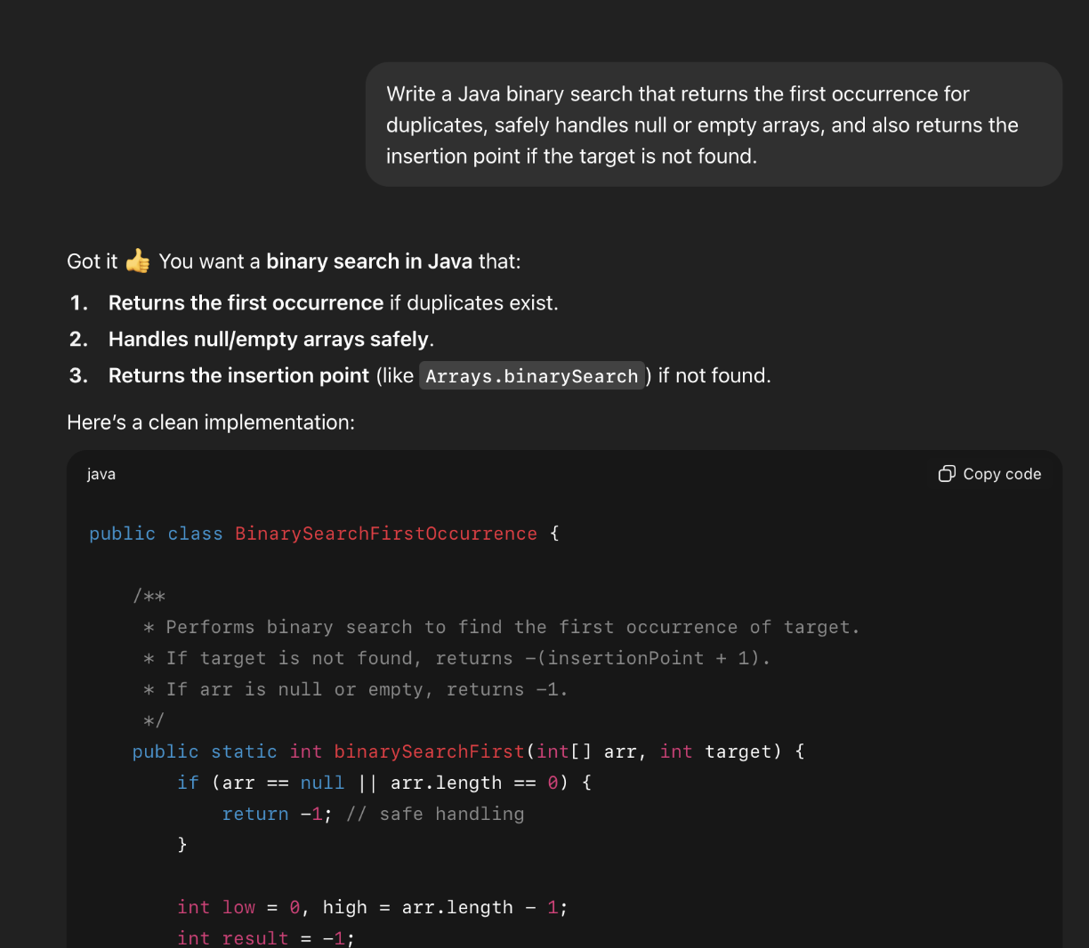
2. Gemini Reprompted and Output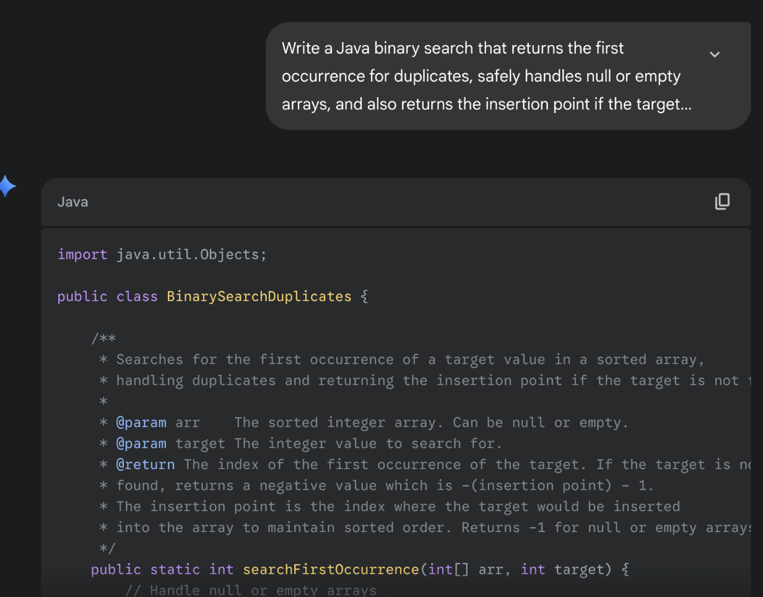

3. Team Reflection
This project made it clear that AI-generated code should never be accepted at face value. On normal inputs, the solutions seemed correct, but once we introduced negative edges, duplicates, or empty arrays, the blind spots became obvious. We learned that AI does not reason about problem constraints in the same way humans do. Instead, it produces the most straightforward version of an algorithm, often skipping validation and ignoring special cases. The key insight was that AI is a fast helper, not a substitute for critical thinking.
We divided responsibilities by assigning each member a different algorithm to test. This way, one person worked on Dijkstra, another on K-Means, another on Quicksort, and another on Binary Search. After running our own tests and documenting failures, we met to share results and compare patterns. This structure let us explore more ground efficiently while still collaborating closely. By pooling our findings, we noticed how often the same failure types reappeared across different tools and problems.
Debugging these programs required a different mindset than debugging human-written code. Instead of just fixing bugs directly, we often had to re-prompt the AI with clearer instructions. Sometimes this worked and the tool improved its output (e.g., K-Means with better input checks), but other times it repeated the same error (e.g., Quicksort stability). This process taught us the importance of designing targeted test cases and practicing precise communication with AI systems. Most importantly, it showed that human oversight, careful testing, and teamwork are essential to make AI-assisted programming effective.

Project 0 - Group 3:
K, Ghaayathri Devi #10
Katakam, Pavan Praneeth #12
Papadopoulos, Panagiotis #19
Patel, Raaj Atulkumar #20

